

Table of Contents

**Introduction 1**

**Description Model 1**

**Class Diagram 1**

**Use Case Diagram 1**

**Use Case Scenarios 1**

**System Sequence Charts 1**

# **Introduction**

*Describe the purpose of this requirements document and outline what it contains.*

# **Description Model**

*Using text, describe the requirements for your system. Expand on the function section from your project plan. Include requirements for the following categories: Output, Input, Processes, Performance and Security.*

Similar Taste Section Requirements : For a similar taste section to even begin showing up to the user, they must be logged in. Additionally, they must be on an account with at least 10 songs previously listened to, to begin building a music profile for the user. As a security measure, the entire section will remain locked until that criteria is met. Once 10 songs have been imputed and recorded by the system, the output will be the similar taste section unlocking to the user.

Socialization of Spotify Requirements : For the social media section of Spotify+, it will remain locked until the user is logged onto an account (security measure). This met requirement also unlocks to the user the activity feed. With the unlocked activity feed, the user can input text and attach songs/playlists to post on the page. Once a user clicks send, the output is the successful post by the system, displaying his post onto the feed for friends to see. For a user to begin sending direct messages, they must have a friend added, the message button remains locked until that requirement is met. Once a user inputs by adding a friend, the system output is the “friend is added, and the direct message option unlocks.” After direct messaging unlocks the user can input text, with an attached song/playlist to send to a user. Once sent the output by the system is the sent message to the selected friend.

Push notifications Requirements :

For notifications to be enabled, a user must be logged into an account. The system will ask the user for notification permission, if declined the user will receive no notifications. It is required by the system to accept notifications, to begin sending them. This following input and output requires the user to first follow the artist (if not followed, notifications won’t be sent): Once an artist inputs a new song/album to the system that is relevant to a user’s music profile, the system output is that user is notified of its release via notifications. Once a user inputs to the system a direct message, the output is a notification sent to the user receiving the message.

Music Tags Requirements :

For the ability to set music tags, the user must first be logged into an account. It is required that the user first attains a minimum of 5 songs added in their library, before attempting to categorize them via tags. Once criteria is met the following input/outputs unlock to the user: If the user decides to input by “tagging a song” the system output prompts the user to enter the name of a tag to add the song to. The user can then input a tag name, in which the system would output the created tag in the user’s library with the selected song.

Collaborated Queue Requirements :

For the ability to create a collaborative queue, the user must first be logged onto an account. Additionally, they must have the friend added on Spotify+. Furthermore, the user and friend must have an internet connection to send and receive songs to the queue. Once requirements have been met, the following inputs/outputs can occur. A user can input to the system by clicking on the collaborated queue button, the system outputs by allowing other users to connect. Once a user is connected they can input to the system a song to add to the queue, the output by the system is the song added to the queue’s host. As a security measure, a max of 5 songs can be added at a time per each connected user, to avoid performance delays/issues.

# 

# 

# 

# 

# 

# 

# **Class Diagram**

*Create a class diagram. The Class Diagram should contain all of the system objects, their attributes, and any known methods. This diagram may be included as a separate file – it does not need to be inserted into this Word document.*

# 

# 

# 

# 

# 

# 

# **Use Case Diagram**

*Create a Use Case Diagram for all of the "uses" of your system. This diagram may be included as a separate file – it does not need to be inserted into this Word document.*

# 

# 

# 

# **Use Case Scenarios**

*Create a full description Use Case Scenario (detailed descriptions) for each use case of the system. This full scenario should include an enumerated list of steps involved in the activity as well as any exception conditions.*

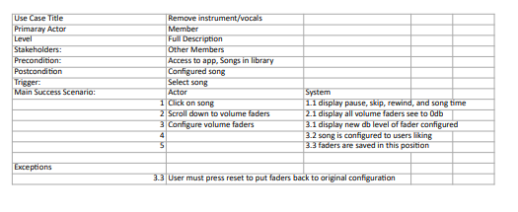

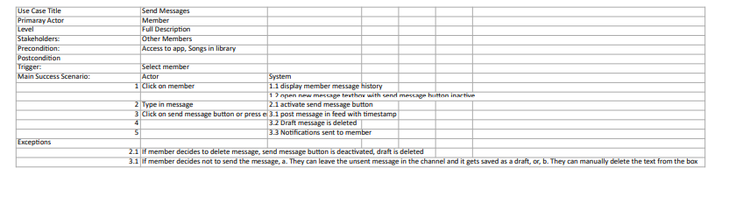

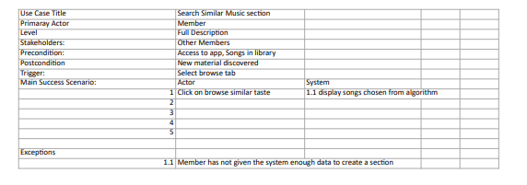

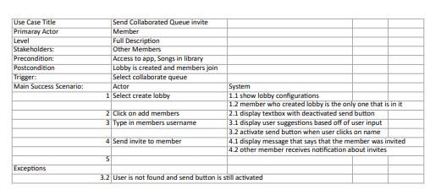

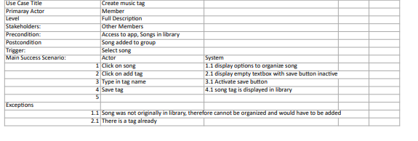

# **System Sequence Charts**

*For each Use Case Scenario, provide a sequence diagram. Use your class diagram, use case diagram and scenarios to create the corresponding System Sequence Diagram*.